PORT OF OLYMPIA  Harbor Patrol | 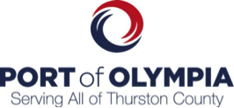
mission statement | Policy 1.0
PURPOSE:  To establish a clear statement for the Mission of the Port of Olympia Harbor Patrol. | Adopted: 09/01/2015  Revised:

policy
The Mission of the Port of Olympia Harbor Patrol is to:
- Ensure Security of the Port of Olympia and its Customers
- Patrol Surveillance
- Terminal | Marinas | Boatyard
- Promote Marine Safety
- Boater Education
- Special Events Patrols
- Ship Escorts
- Provide Emergency Response
- Search & Rescue
- Aid to Distressed Vessels
- EMS & Fire Responses

